Introduction

This page will explain some of the features of the software and guide you through a possible workflow.

Welcome Page
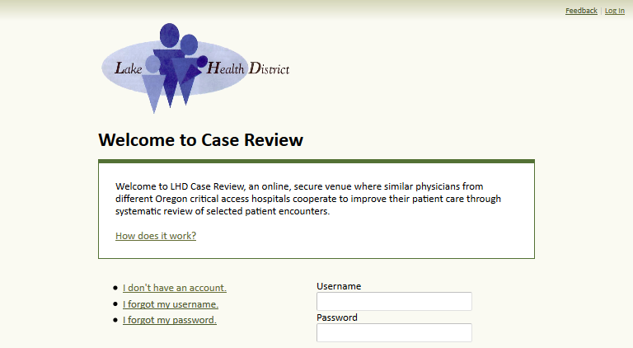
If you have an account and remember your credentials, you can log in at the welcome page. Otherwise, tools are available to request an account, recover your username, or reset your password.

Sign Up Page
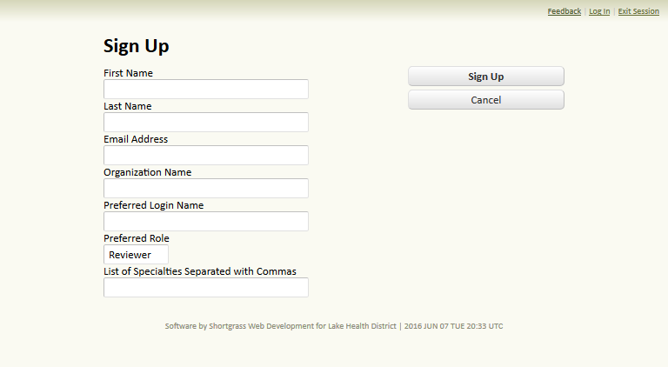
Prospective users can request an account by submitting their first and last names, email address, organization name, and a login name. An administrator may accept or reject the request. Account attributes are subject to change based on administrative discretion. When a new account is created, a notification email may be sent to prompt the new user to establish a password.

User Roles
There are three kinds of users:

Admin
Administrators are responsible for managing organizations and users and guiding each case submission through the review process.

Coordinator
Coordinators submit case review requests and assign referred cases to reviewers in their organization. They also manage users in their organization.

Reviewer
Reviewers receive case review assignments from their coordinator.

Submission Status
Cases submitted for review adhere to this phase progression:
Request and Submission (upload case file) → Approval and Referral → Review → Retrieval

Typical Workflow
Although workflow variations are possible, the software was designed with the following workflow in mind.
1. A requesting coordinator creates a request by clicking the Create button on the Requests page of her dashboard.
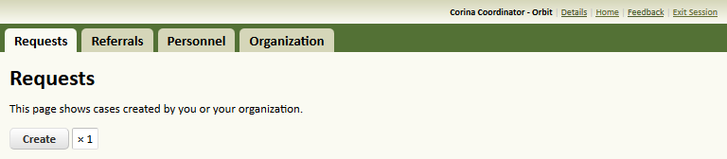

2. She enters appropriate values for each of the fields to describe the case she will be sending, then clicks the Submit Request Button.
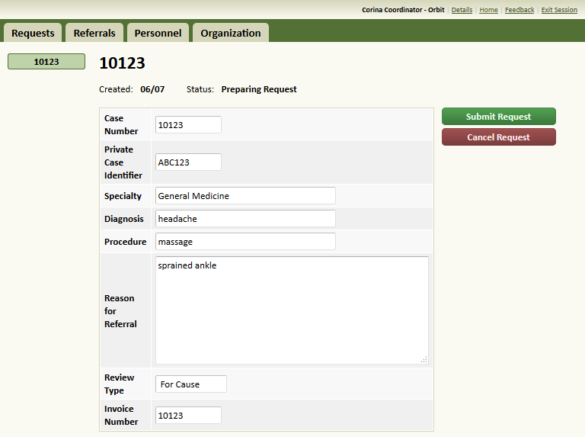
3. She is taken to a page where she can upload case files. She should organize files by selecting appropriate target folders.
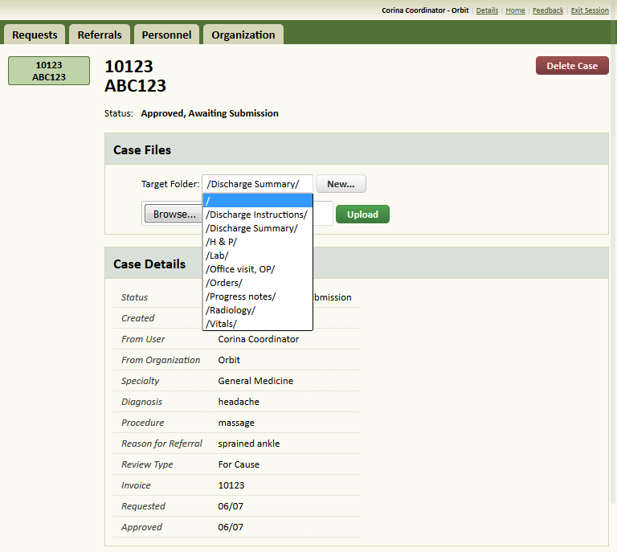
4. With one or more files uploaded, the Submit Case button appears. The requesting coordinator clicks the Submit Case button to let the administrator know the case is ready to be reviewed.
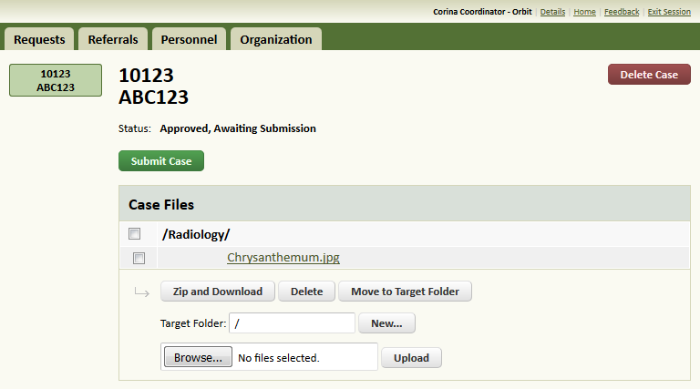
5. An administrator finds the case and refers it to a reviewing facility.
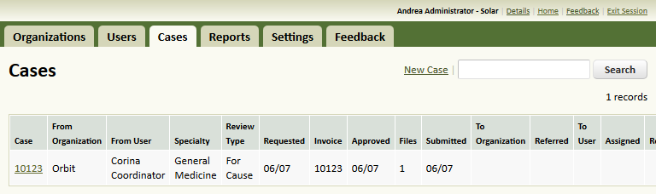
6. The requesting coordinator can see the date the case was referred.
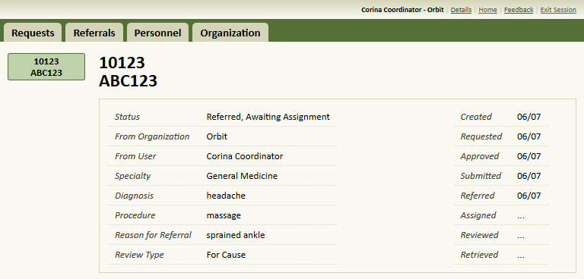

7. The reviewing facility receives the case for review.
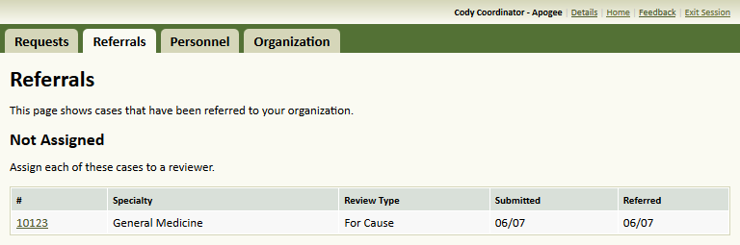
8. The reviewing coordinator makes an assignment to a reviewer physician at the same organization by entering the physician's name and clicking the Assign button.
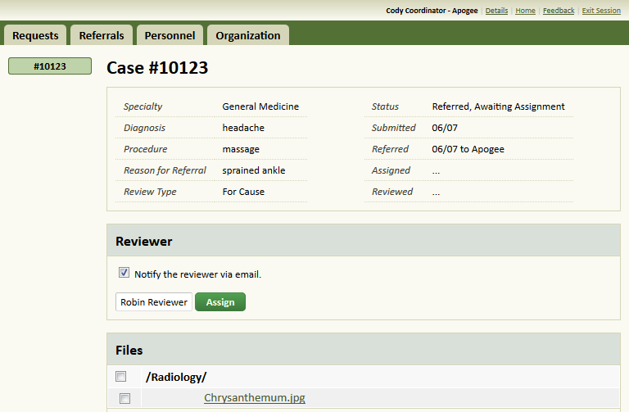
9. The coordinator can print a paper review, or act on behalf of the reviewer by using the Impersonate Reviewer button. This can be useful if the reviewer physician prefers to work offline with paper or dictation.
10. The reviewing physician finds the case on the Assignments page of his dashboard.
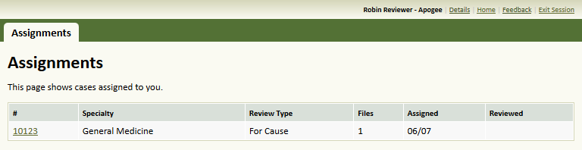
11. The physician examines the case and completes the review form electronically or completes a paper review form and uploads it into the system. When he is done, he clicks the Submit Review button.
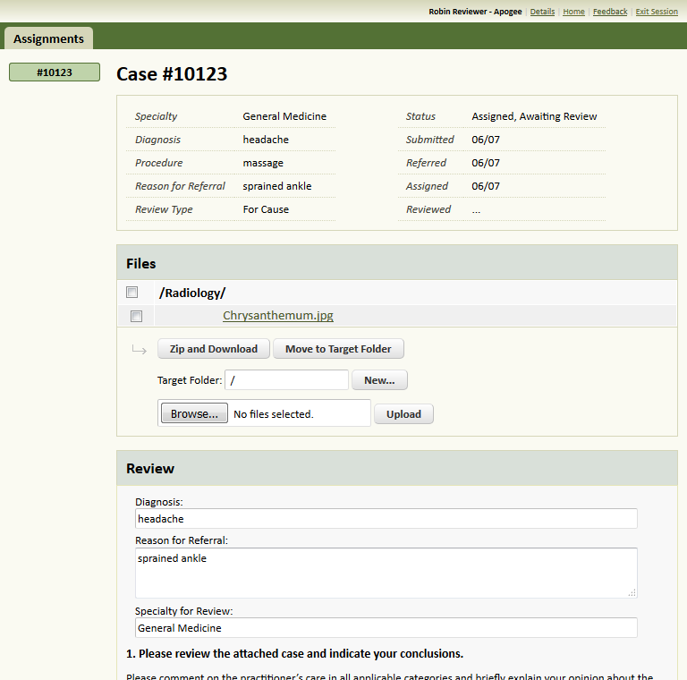

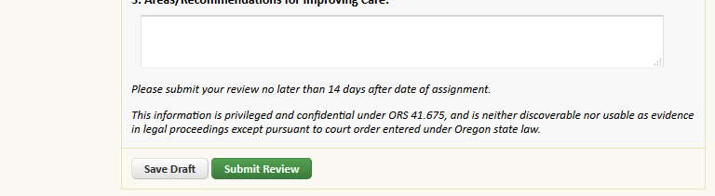
12. The requesting coordinator receives an email notification that the case has been reviewed and finds the case under the heading Reviewed.
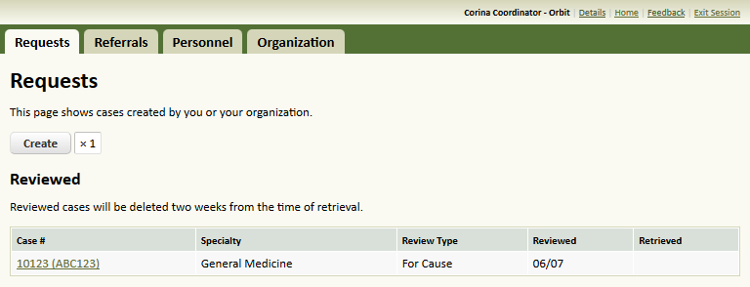
13. On the case details page, the coordinator must click the Retrieve button to access the review.
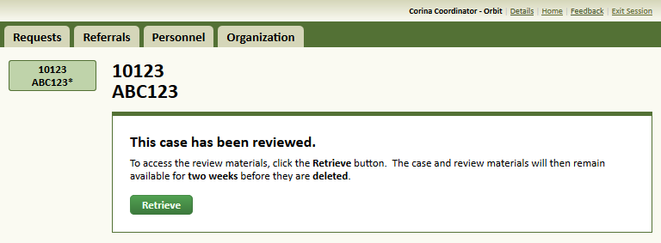
14. The requesting facility can now print the completed review and download any files that may be attached. When she is done, she can manually delete the case or allow it to expire in 14 days.
